Lesson 16: Perimeter and Area of Quadrilaterals
GETTING YOURSELF READY
Materials:  Mini whiteboards  Student Handout photocopies  Practice completed and photocopied  Misconception to New Understanding Sheets  Grid paper, measuring tools  Post-its |  |  | Your Preparation:  Put last night’s Independent Practice Answer Key and the Misconception to New Understanding Worksheet on a table for students to pick up on their way in to class. |  |  | Agenda with times:  Do Now and Purpose: 5 minutes  Key Vocabulary: 3 minutes  Building the Skill: 15 minutes  Structured Practice: 15 minutes  Guided Practice: 10 minutes  Closure: 2 minutes
GETTING YOUR STUDENTS READY
*Do Now:
Do the Do-Now on the handout.
Objective: Today you will be able to understand the perimeter and area of quadrilaterals. |  |  |  | Proving Behavior: By finding the perimeter and area of quadrilaterals in word problems with 80% accuracy.
Purpose: Perimeter and area are important to know and understand so that you can make accurate calculations and measurements when constructing or planning out space. For example, if you were going to have a party and you had a room with certain dimensions, you would need to understand perimeter and area to determine if you could fit enough chairs in the room to host everyone you wanted to invite to the party.
Key Vocabulary: (from Glencoe.com)
Create vocabulary cards with these definitions and a picture to represent them and hang on the word wall. Use the cards to ask the students the given questions about the vocabulary and have them respond chorally or on their mini-whiteboards.
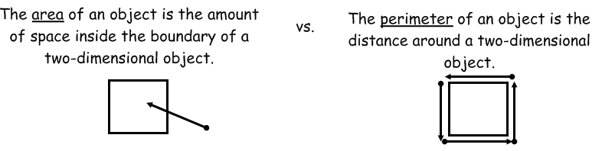
BUILDING THE SKILL
Area and Perimeter of Quadrilaterals | Say/See: Use the visual to think aloud why perimeter gives us an answer that we label units and area gives us an answer that we label units².  Do: Have the students partner teach the explanation about why they have to label their answer to perimeter units and the answer to area units².  Say/See: Show how they would use the area and perimeter formula to calculate the given example of a square with a side length of 5.  Do: Have the students calculate the example of the square with a side length of 11 and show you their work on their whiteboards. Make sure their labels are correct.  Say/See: Think aloud how to find the area and perimeter of a rectangle with the length of 5 and width of 6.  Do: Have the students calculate the example of the rectangle with the length of 11 and the width of 2 and show you their work on their whiteboards. Have the students complete 1-4 on their own as a whiteboard drill. Then, have them complete 1-4 of the next section as a whiteboard drill. Have the students work with a partner on number 5 and show you their work, then complete 6-8 on their own and show you their work.  Say/See: Think aloud how to find area and perimeter of an object that can be divided into squares and rectangles. Use graph paper to demonstrate.  Do: In your group, use the graph paper to draw a picture using only the grids to compose the picture. Give the perimeter and area of the picture.
PRACTICING THE SKILL
*Structured Practice
 |  | In groups, go around the classroom and measure the perimeters and areas of the surfaces in the classroom. Use post its to post on the surfaces with the perimeter and area of the surface.
Time: 5 minutes  Materials: Word Problems  Group Size: Pairs  Materials: Mini Whiteboards |  | There are two sets of word problems for the Structured/Guided Practice. Have the students complete the first problem of each section, one at a time, with a partner and hold up their whiteboards for you to see their answer. Because they are word problems, require the students to use their strategy of visualizing. They should draw some picture to represent the problem before solving. If the students are proficient, they may go on and use the remaining problems as their Guided Practice. If they need more help, you may do a whole class think aloud or give them another problem in the section to complete with a partner before releasing them to Guided Practice.
*Guided Practice (the proving behavior of the objective monitored by teacher)
Assignment: Guided Practice Handout. Have the students complete the remainder of the word problems. Make sure they show their visualization for each problem. |  |  |  |  | Criteria for Mastery: 80% of the remaining problems.
Explain Homework: Independent Practice Handouts.
*Closure: Work with a partner to complete the closure questions.

